Amino Acids Paper
Name
Institution
Date

Amino Acids Paper
Question One
Amino acids are the building blocks of proteins and are small organic molecules consisting of a central carbon group linked to four constituent groups namely, an amino group, a carboxyl group, a hydrogen atom and a constituent called a side chain. Proteins are formed from twenty amino acids except one, with each of the amino acids containing unique side chains. These chains can bond to one another by holding a protein in a particular conformation; hence the concept of L-amino acids and D-amino acids. Cells only use the L-forms because they manufacture the L-amino acids and incorporate them into proteins. Chirality also contributes to the configurations of amino acids (Pundir et al. 2018). All amino acids are chiral, that is, they have at least one chiral center, except glycine which has a side chain of hydrogen atom only. In contrast, all the others have four different groups attached to the central carbon. This characteristic enables the amino acid compound to exist as a pair of non-superimposable mirror images hence the two chiral forms of amino acids are “D” and “L” which mean right-handed and left-handed configurations respectively. Since L-amino acids are only found in proteins, and the proteins are essential for maintaining the cell, the L –amino acids are thus directly linked to the evolution of life. D-amino acids are precisely found in cell walls of bacteria which are made up of carbohydrates and not in bacterial proteins (Pundir et al. 2018). Thus they are not involved in the metabolic processes of eukaryotic organisms. With the presence of only D-amino acids in the cell of an organism, it can be dangerous to an organism because of the necessary biological processes that must occur within the cells. These processes can only happen in the presence of L-amino acids. Presence of D-amino acids in bacterial cell walls might be also essential because, for example, in the mammalian gut exists bacteria which the cells in the mammalian body could use by metabolizing bacterial D-amino acids and also help in modulating the inner immune system. So, I think that an organism cannot live when it is wholly composed of only D-amino acids because the cells of the organism require L-amino acids for a metabolic pathway.
Figure I below show the structure of an amino acid compound.
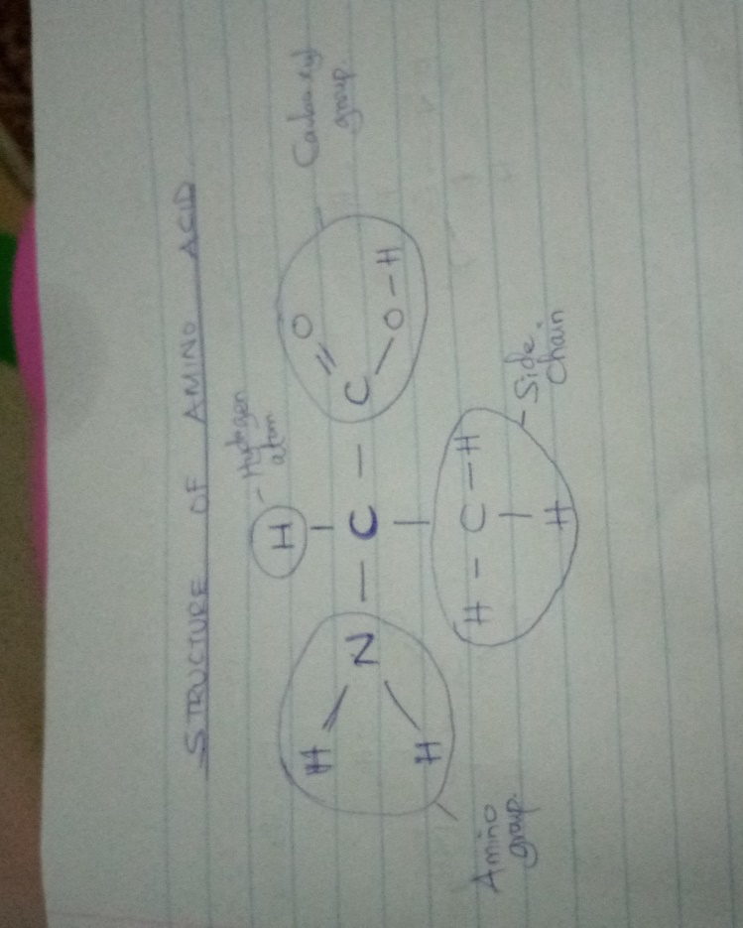
Figure II below shows the configurations of L-amino acids and D-amino acids with Alanine as an example.
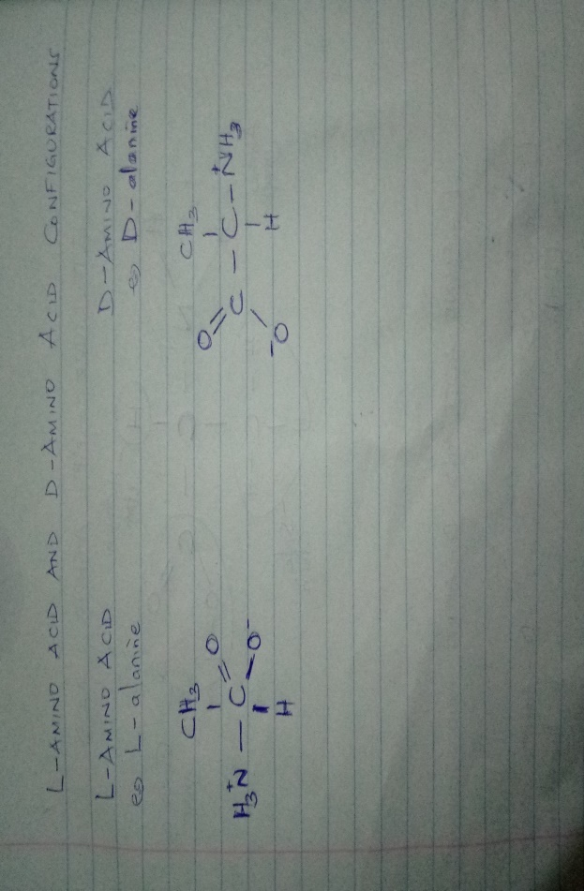
Question Two
The acid dissociation constant (pKa) is a method used to indicate the strength of an acid. Aspartic acid, in this case, is an acidic amino acid with a pKa of 3.9, which is subject to change to even higher values due to the local environment in a peptide. The pKa of a side chain of aspartic acid occurring interiorly in the protein can be different from the chain happening on the outside of a protein because of the active sites in which the local environment plays a role to a larger effect (Wu et al. 2019). In aspartic acid, the interior side chain might be hydrophobic which prevents it from losing protons to water and getting charged; hence their pKa may shift to higher values. Exteriorly, the hydrophilic site allows the formation of hydrogen bonds within the peptide backbone and to water, therefore altering the charge state depending on the environment. The exterior side-chain functions as a proton donor hence changing the pKa value to a lesser one than that of the interior side hence a disparity in the pKa values between the inside and outside side chains.

References
Pundir, C. S., Lata, S., & Narwal, V. (2018). Biosensors for determination of D and L-amino acids: a review. Biosensors and Bioelectronics, 117, 373-384.
Wu, J., Wang, J., & Zhao, H. (2019). Solubility of d-Aspartic Acid in Several Neat Solvents: Determination, Modeling, and Solvent Effect Analysis. Journal of Chemical & Engineering Data, 64(6), 2904-2910.
McMurry, J. E. (2014). Organic chemistry with biological applications. Cengage Learning.

